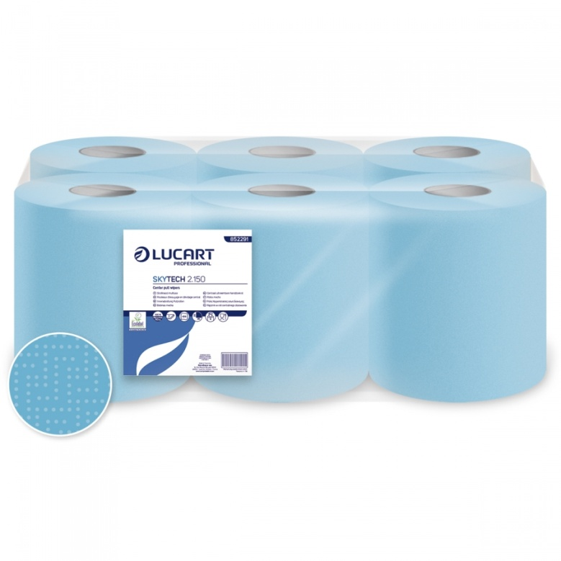
LUCART SKYTECH 150
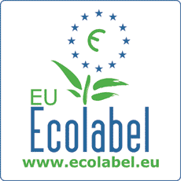

- Is your wiping paper - FOOD CONTACT APPROVED?
- Are you handling, processing or preparing our greatest natural resource – Food & Drink?
Unfortunately, some of the blue paper used in Ireland is of poor hygienic origin, poor quality; contains toxins & harmful dyes and are not safe or approved for food contact.

The National Standards Authority of Ireland (NSAI) is now inspecting food preparation areas in respect of conformance and traceability.

Safeguard your processes by using our fully traceable and
‘Food Safe Certified’ centre feed wiping rolls.

- Food Safe Certified – This means that both the paper and the blue dyes are food contact safe. They conform to best practice as laid down by the Irish Food Safety Authority.
- The product is ECO-Label Certified – giving you an added environmental benefit.
- The product Conforms to EU Directive 1935/2004.
- The product is fully traceable.
Code 852291 Strong Blue 2ply Paper 150 metres x 20cm 429 Sheets per Roll

