**Kitchenmaster | 11 Comber Road | Carryduff | Belfast | BT8 8AN Email:** [**sales@kitchenmaster-ni.com**](mailto:sales@kitchenmaster-ni.com) **Web:** [**www.kitchenmaster-ni.com**](http://www.kitchenmaster-ni.com)

**Head Office:** 028 9081 4777

**PRODUCT GUIDANCE SHEET**

Reload No.2

# CONCENTRATED FLOOR CLEANER AND DEGREASER

A powerful detergent cleaner formulated to remove the heaviest soil deposits and ingrained grime from all types of hard floors. To aid product recognition the Reload No.2 product label, the solutions, both concentrated and diluted, and the label on the trigger bottle are Blue.

Product Name: Reload No2

Description: Super concentrated odourless floor cleaner and Degreaser

Pack Size: 4x2Lt

Pallet Size: 84

Product Code: REAQUADEG-4X2L

# HOW TO USE

Suitable for a wide variety of cleaning operations in housekeeping and building services applications as a damp wipe surface/floor cleaner. It is also suitable for use as a damp wipe cleaner on all hard surfaces. Reload No.2 is non-biocidal and is therefore suitable for domestic floor cleaning applications in hospitals where anti-bacterial resistance is a concern.

Always dilute Reload 2 before use. Reload 2 can be applied as a spray bottle solution for hard surfaces or as a “bucket and mop” solution for floors and larger areas. A Kitchenmaster bottle-fill or bucket-fill dispenser offers a simple way to control dosage and maximise economy, see instructions as follows:

## Bucket Fill Instruction – Manual and Water Fed Units:

1. Pull GREEN lever in an upward direction until it CLICKS to prime the unit.
2. Manual unit - Fill mop bucket with water pull lever towards you in an upward direction until it CLICKS. This is now ready to vend.
3. To vend product PUSH lever downwards. The concentrate will be dispensed into the bucket at the correct dilution to water.
4. Water fed unit – Depress the button and fill mop bucket with blended chemical and water to the desire amount into the mop bucket.
5. It is suggested that 2-3 plunges are sufficient product in a 10Ltr mop bucket of hot water.

**Issue Date: May 2021**

**Kitchenmaster products are manufactured under ISO 9001 & registered Quality Management System**.

.

## Bottle Fill Instructions:

1. Unscrew trigger spray from bottle and fill with water to the top of the label.
2. Insert bottle neck on to the dispensing nozzle and push upwards – priming the unit.
3. Position spray bottle on the base of the drip tray to allow vending to commence.
4. PULL lever towards you in an upward direction until it CLICKS. This is now ready to vend.
5. To vend product PUSH lever downwards. The concentrate will be dispensed into the bottle at the correct dilution to water.
6. Remove the bottle from the base and screw trigger spray onto the bottle. Turn bottle upside down to ensure thorough mixing has occurred.
7. WAIT for the green indicator to reappear in the window before inserting the next bottle for vending.

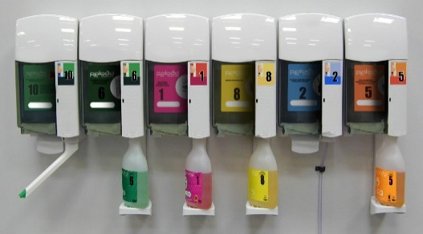

# SAFETY ADVICE

Causes severe skin burns and eye damage. May be corrosive to metals. Do not breathe vapours or spray. Wear protective gloves, protective clothing and eye/face protection. IF SWALLOWED: Rinse mouth. Do NOT induce vomiting. IF ON SKIN (or hair): Remove/Take off immediately all contaminated clothing. Rinse skin with water/ shower. IF IN EYES: Rinse cautiously with water for several minutes. Remove contact lenses, if present and easy to do. Continue rinsing. Immediately call a POISON CENTRE or doctor/physician.

**For detailed advice on safe handling and storage of the concentrated product refer to the product Safety Data Sheet.**

FOR INDUSTRIAL & INSTITUTIONAL USE ONLY. Keep out of reach of children. Note: Diluted solutions are not classified as hazardous



***COSHH STATEMENT***

COSHH is a law that requires all employers to take steps to control substances (chemicals) that may cause harm to employees, contractors, and visitors to the workplace. Every work environment will be different in terms of the hazardous chemicals that are present, and how these are used, and individual assessments may be necessary to consider how chemicals can be handled and stored safely, in addition to ensuring that appropriate PPE and training is provided for employees. Product MSDS and Product Guidance Sheets are intended to help when carrying out a COSHH assessment, however if further advice is needed with regard to specific issues in your work environment, we are happy to provide advice**. E-Mail Technical:** [sales@kitchenmaster-ni.com](mailto:sales@kitchenmaster-ni.com)